Q2)

GC content = (72+129)/(131+72+129+100) = 46.5278 %

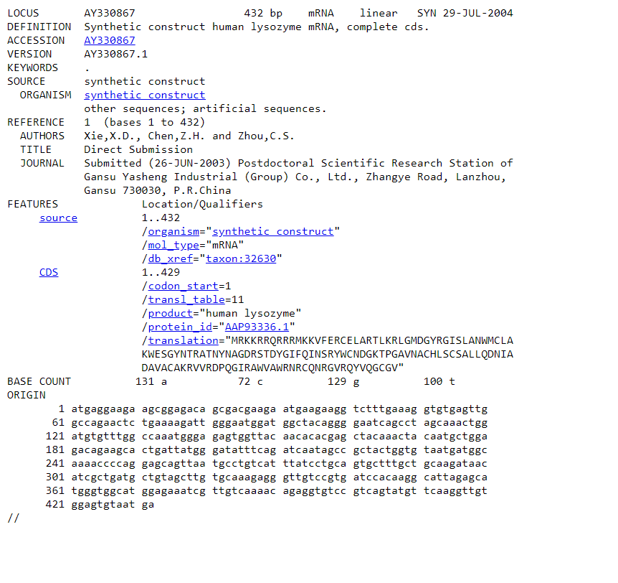

Q8)

